HW.

-파라미터

logic = LogisticRegression(solver='lbfgs',random_state=1, max_iter=100)  
svm1 = SVC(kernel = 'linear',C=1.0, gamma=100)  
svm2 = SVC(kernel = 'rbf',C=1.0, gamma=100)

-ensemble

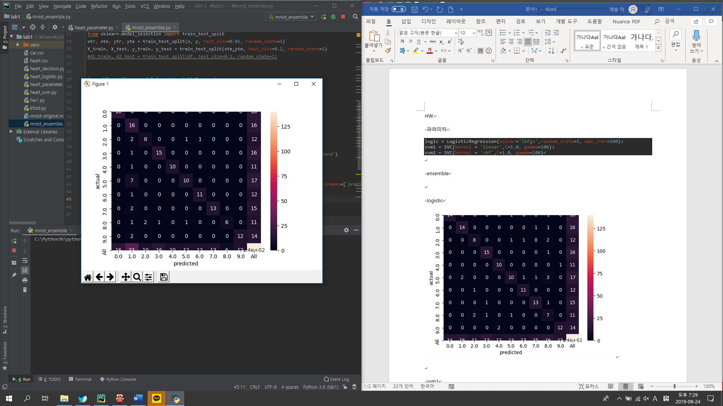

-logistic

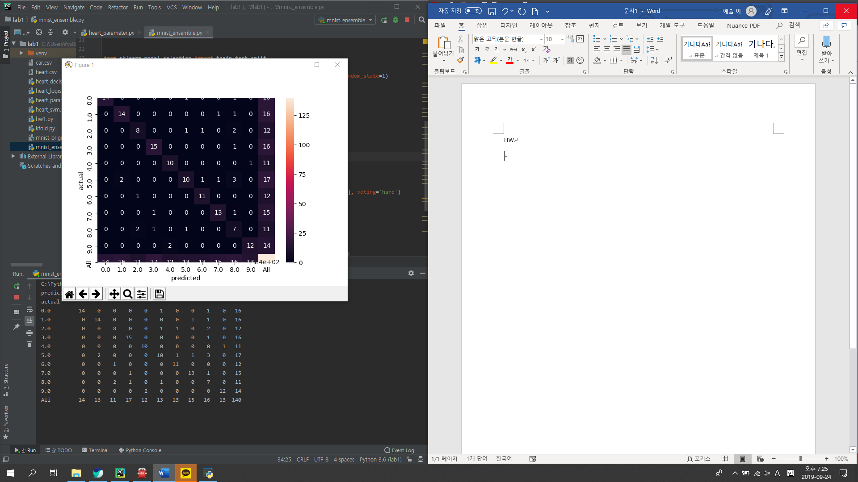

-svm1

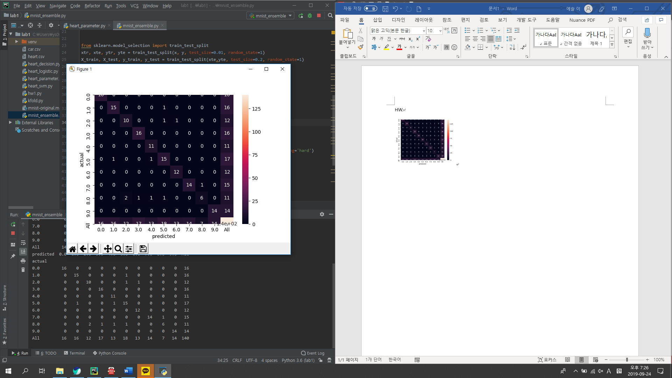

-svm2

